Suppose the age of cats in Taiwan is Normally distributed with a mean of 5 years and 6 months. If the standard deviation is known to be 2 years and 4 months, what is the probability that 10 randomly selected cats are between 4 and 6 years old ?

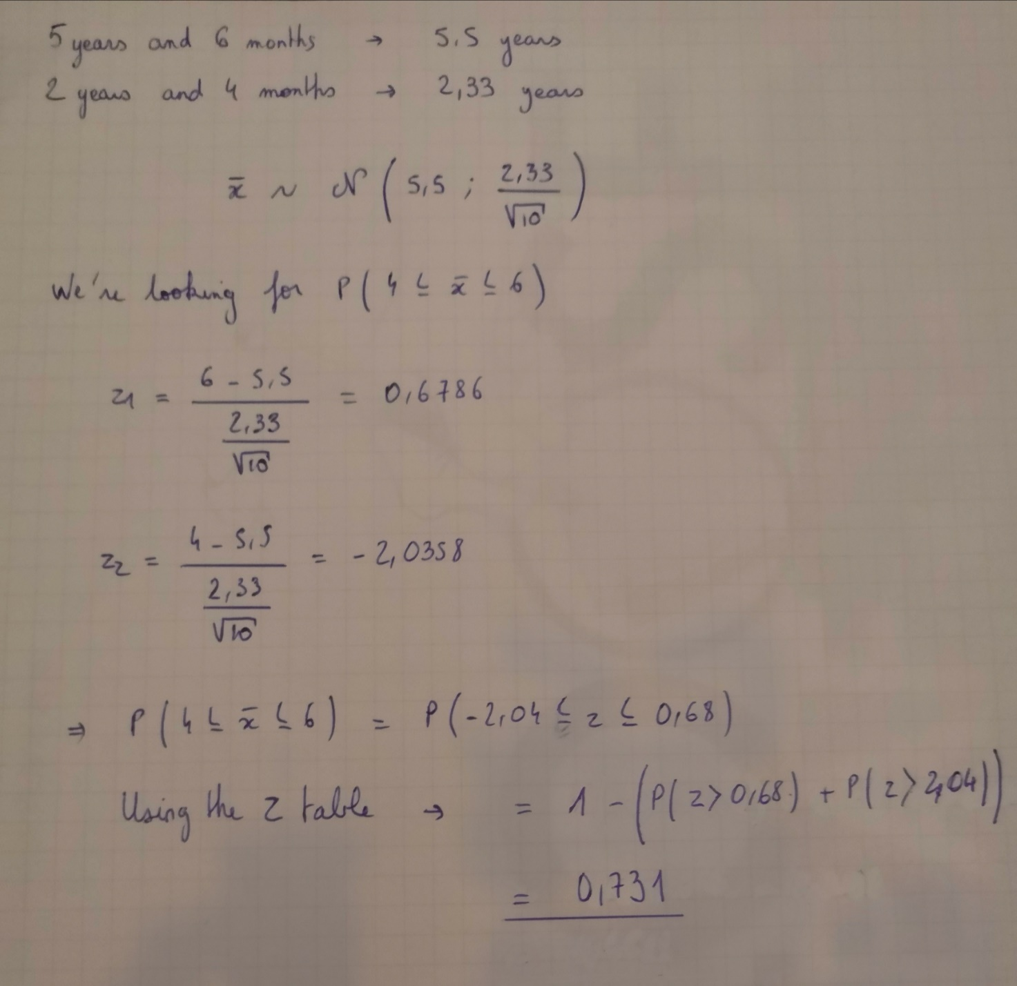

You love to travel around Taiwan and spends $50 for a day of travel on average (with a standard deviation of $10). You are planning to go to Hua Lien for on the long holidays for a week. You plan to bring a total of $385 for the whole trip. What is the probability that you will run out of money?

P (run out of money)

= P (total trip cost more than $385)

= P (your average spending for a day in that trip is more than $55)

Use sample mean with:

n = 7 (a week) $μ=50, σ=10$

$$σx= \frac{σ}{\sqrt{n}}= \frac{10}{\sqrt{7}}=3.78(rounded up)$$

55 – 50 = 5 above the $mean$

$$\frac{55-5}{3.78}= \frac{5}{3.78}$$

$$=1.32 (rounded up)$$

Then use Z-Table

P (your mean is more than 1.32 unit of standard deviation above mean)

= 1 - 0.90658

=

Or 9.342% that you will need more money than you bring

